Of course. For an Assistant Administrative Officer (AAO) position at NICL, the interview will test not only your insurance knowledge but also your administrative aptitude, problem-solving skills, and understanding of public sector undertakings.

### Category 1: Company-Specific & Industry Knowledge

These questions test your interest in and knowledge of NICL.

- **Why do you want to join NICL and not any other insurance company?**
I have read about NICL IT job is a perfect match for my skills. It allows me to use my experience in a large, respected government company. It offers a unique combination of job stability, a trusted brand, and the opportunity to serve a wide range of people across India, for me this is more meaningful. Most importantly, it offers me a clear and stable path to build my long-term career, which is exactly what I am looking for."

I want to join NICL specifically because it is a leading government-owned insurance company. It offers a unique combination of job stability, a trusted brand, and the opportunity to serve a wide range of people across India. For me, this is more meaningful, as it allows me to contribute to the public good while building a secure long-term career.

- What do you know about the General Insurance Business (Nationalisation) Act, 1972, and its significance for NICL?
The General Insurance Business (Nationalisation) Act, 1972, was a landmark law passed by the Indian government. Its main goal was to transfer the control of the general insurance industry from private companies to the government for the benefit of the public.
Its significance for NICL is fundamental:
- Creation of NICL: This Act led to the merger of 21 foreign and 11 Indian insurance companies. From this consolidation, National Insurance Company Limited (NICL) was officially formed as one of the four subsidiary companies under the newly created General Insurance Corporation of India (GIC).
- Defined Social Purpose: The Act gave NICL a clear social mandate, moving its focus beyond profit to providing insurance security to all sections of society, especially in rural areas.
**
3.**Can you name the four public sector general insurance companies in India?** (Follow-up: How is NICL positioned among them?)
The four public sector general insurance companies in India, often called the "PSGICs," are:
- The New India Assurance Company Ltd.
- United India Insurance Company Ltd.
- National Insurance Company Ltd. (NICL)
- The Oriental Insurance Company Ltd.
All four were originally subsidiaries of the General Insurance Corporation of India (GIC) until 2002 and are now wholly owned by the Government of India.

Follow-up: How is NICL positioned among them?
NICL holds a position of historical significance and strong market presence.
- Geographical Strength: It has a very strong and extensive network, particularly in Eastern and Northern India, giving it a deep reach into the rural and semi-urban markets.
- Brand Trust: As a legacy company formed in 1906 and later nationalized, it carries a century-old reputation for trust and reliability, which is a hallmark of all public sector insurers.
- Key Player: While New India Assurance is often considered the market leader and the largest in terms of global presence and premium, NICL consistently remains one of the key pillars of the public sector general insurance market in India, known for its vast portfolio and commitment to its social objectives.
In short, NICL is not just one of the four; it is a foundational pillar of India's public sector general insurance landscape with a distinct regional strength and a trusted brand.
NICL vs NIACL

The Core Difference
The main difference is in what they insure:
- NICL (National Insurance Company Limited): Provides General Insurance (non-life insurance).
- NIACL (The New India Assurance Company Limited): Also provides General Insurance (non-life insurance).
So, both are in the same business. The difference lies in their identity, market position, and specific operations.

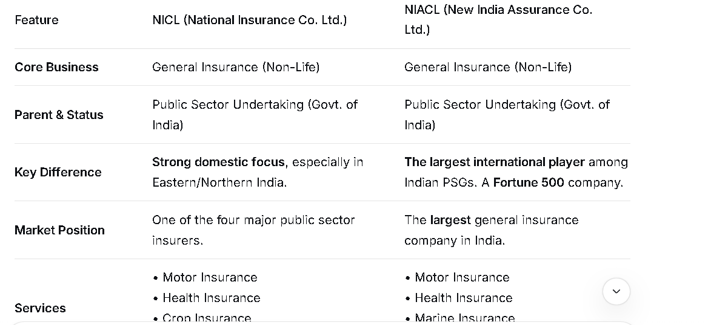

- **What are the biggest challenges and opportunities facing the general insurance industry in India today?**

Biggest Challenges
- Low Insurance Penetration: Despite a large population, a significant portion of India remains uninsured or underinsured. Many people still view insurance as a tax-saving tool or a regulatory obligation (like car insurance) rather than a necessary financial safety net.
- Intense Price Competition: The market is highly competitive, especially in products like motor and health insurance. This "price war" pressures profitability, making it difficult for companies to invest in innovation and superior customer service.
- High Combined Ratio: In simple terms, this means that for many companies, the money paid out in claims plus operating expenses is often very close to, or sometimes even exceeds, the premium earned. This makes it hard to be profitable in the core business of underwriting.
- Fraud and False Claims: The industry faces significant losses due to fraudulent claims, particularly in the motor and health segments. This increases costs for everyone and erodes trust.
- Technology Legacy Systems: Many insurers, especially public sector ones, rely on old IT systems which make it difficult to integrate new technologies, offer seamless digital experiences, and process claims quickly.

Biggest Opportunities
- Massive Untapped Market: The low penetration rate is itself the single biggest opportunity. There is immense potential for growth, especially in rural India and among the middle class.
- Rising Health Awareness & Costs: The COVID-19 pandemic was a watershed moment, making people acutely aware of the need for health insurance. Rising medical costs are driving individuals and families to seek financial protection, creating a huge growth avenue.
- Government-Led Schemes: Initiatives like Ayushman Bharat (PM-JAY), Pradhan Mantri Fasal Bima Yojana (PMFBY - crop insurance), and Pradhan Mantri Suraksha Bima Yojana (PMSBY) have massively increased insurance awareness. They provide a platform for companies like NICL to reach millions of new customers.
- Technological Advancements (InsurTech): Technologies like AI, IoT, and Big Data present massive opportunities:
  - AI: For faster claims processing, fraud detection, and personalized pricing.
  - IoT: For usage-based insurance (e.g., charging car insurance based on how you drive).
  - Digital Distribution: Selling policies directly through apps and websites, reducing costs and reaching younger customers.
- Product Innovation: There is a growing demand for specialized products like cyber insurance, parametric policies for weather risks, and insurance for the gig economy workforce.

why peoples in india now buy insuarnce product more

1. Rising Financial Literacy and Awareness
- Understanding Risk: People are becoming more aware of life's uncertainties—critical illnesses, accidents, and untimely death. They now see insurance as a crucial tool for risk management, not just a tax-saving instrument.
- Digital & Social Media: Financial influencers ("FinFluencers"), news about medical emergencies, and educational content on platforms like YouTube and Instagram have demystified insurance concepts for the masses.
- Government Campaigns: Initiatives like "Jeevan Jyoti Bima Yojana," "Pradhan Mantri Suraksha Bima Yojana," and "Ayushman Bharat" have brought the concept of insurance to the rural and lower-income populations, creating a foundational level of awareness.
- Rising Incomes & Middle Class: As India's economy grows, a larger segment of the population has disposable income to allocate towards securing their future.
- Healthcare Inflation: The cost of quality healthcare is rising dramatically. A single major illness can wipe out a family's lifetime savings. Health insurance is now seen as a financial shield against medical inflation.
- InsurTech Companies: The rise of digital-first insurance providers like Acko, Digit, and RenewBuy has simplified the entire process. Buying insurance is now as easy as ordering food online.
- Simplified Products: These companies offer simple, jargon-free policies with transparent terms, which appeal to younger, tech-savvy customers.
- Comparison & Purchase: Online aggregator platforms (e.g., Policybazaar, Coverfox) allow users to instantly compare dozens of policies on price and features, empowering them to make informed decisions.
- Paperless & Instant: The process is now largely paperless, with instant policy issuance, video KYC, and quick claim settlements.
- Tax Benefits
While not the primary driver anymore, tax benefits under Section 80C (for life insurance premiums) and Section 80D (for health insurance premiums) remain a significant incentive for salaried individuals to purchase insurance.

In a Nutshell:
The Indian general insurance industry is at a crossroads. The challenges of profitability and penetration are significant, but the opportunities for growth through technology, government partnerships, and an increasingly aware customer base are far greater. The companies that can leverage technology to solve traditional problems will be the ones to succeed.

- **How does NICL's role differ from that of its parent company, GIC Re?**

NICL sells insurance directly to customers, while GIC Re sells insurance to insurance companies like NICL.
- **What is "Bharat Griha Raksha" or "Bharat Sookshma Udyam Suraksha"?** (Be prepared for questions on their specific product portfolios).
Of course. This question tests your knowledge of NICL's specific product portfolio, which shows you've done your research.

---

### **Bharat Griha Raksha & Bharat Sookshma Udyam Suraksha**

These are **standardized insurance policies** launched by the general insurance industry, under the guidance of IRDAI. They are designed to be **simple, affordable, and easily understandable** for the common person.

Here’s a breakdown of each:

#### 1. Bharat Griha Raksha (Standard Home Insurance Policy)

* **What it is:** A standardized insurance policy that protects a homeowner's **building (structure)** and its **contents** against various risks.
* **Key Features:**
* **Simple Coverage:** It covers a standard set of risks like fire, explosions, lightning, storms, floods, earthquakes, riots, etc.
* **Two Options:** The policy can be bought for just the **building**, just the **contents**, or both.
* **No Confusing Terms:** It avoids complex wordings, making it easy for a common person to understand what is covered.
* **Affordable:** Designed to be cost-effective to encourage more people to insure their homes.

A "No-Frills" insurance is a basic, low-cost policy that covers only the most essential risks.

**In short: It's a straightforward, no-frills insurance policy to protect a person's house and belongings.**

#### 2. Bharat Sookshma Udyam Suraksha (Standard Micro Enterprise Insurance Policy)

* **What it is:** A standardized insurance policy designed specifically for **Micro, Small, and Medium Enterprises (MSMEs)**.
* **Key Features:**
* **Protects Business Assets:** It covers the business's **building, machinery, stock, and equipment** against the same standard risks as the home policy (fire, flood, earthquake, etc.).
* **Built for Small Businesses:** It addresses the unique needs of small shop owners, workshops, and micro-enterprises who often cannot afford complex industrial policies.
* **Simplified Proposal Form:** The process to get insured is very simple, with a short and easy-to-fill form.

**In short: It is an affordable and simple safety net for the assets of small business owners, protecting them from unforeseen disasters.**

---

### **Why This is Important for NICL:**

As a public sector company with a social mandate, NICL plays a crucial role in offering these **"Bharat" series policies**. They are perfect tools for achieving **financial inclusion** and **deepening insurance penetration** in rural and semi-urban areas, which is a core objective for NICL.

---

### Category 2: Role-Specific & Administrative Skills (AAO)

These assess your suitability for an administrative role.

- **As an AAO, you will handle both technical insurance work and general administration. How will you balance these two?**

I will balance them by prioritizing and scheduling.
- I'll treat them as two parts of one job, not separate tasks.
- I'll use a to-do list to identify what's most urgent and important each day—whether it's a complex claim (technical) or a budget report (admin).
- I'll block out specific times for focused technical work and dedicated slots for administrative duties.
- For routine tasks, I'll use templates and systems to work efficiently.

- **How would you handle a situation where a senior manager has given you a tight deadline, but a subordinate is refusing to cooperate?**

- Talk to the Subordinate Privately: I would calmly have a one-on-one conversation with the subordinate. I would listen to their reasons for refusing—is it a lack of resources, a skills gap, personal stress, or a misunderstanding of the task's importance?
- Explain the "Why": I would clearly explain the critical nature of the deadline from the senior manager and how their role is essential to our team's success. This connects their work to a larger goal.
- Collaborate on a Solution: Instead of just giving an order, I would try to solve the problem with them.
  - If they're overwhelmed, I would help prioritize tasks or see if I can temporarily shift their other duties.
  - If they lack a resource, I would try to provide it.
  - I would offer my support and guidance to enable them.
- Set Clear Expectations: After addressing their concerns, I would firmly reiterate the non-negotiable deadline and their specific responsibilities, confirming their agreement to proceed.
- Escalate if Necessary (as a last resort): If the refusal continues without a valid reason, I would have to formally escalate the issue to my own manager or HR, as the senior manager's deadline must be met. I would inform the subordinate of this step beforehand.

- **What, in your opinion, are the key qualities of an effective administrator in a government organization?**

- Integrity and Probity: This is the foundation. An administrator must be ethical, impartial, and honest, ensuring all actions are fair and beyond reproach. Public trust is paramount.
- Accountability: Taking ownership of decisions and their outcomes, whether positive or negative. Being answerable to the public and superiors for the work done.
- Effective Communication: The ability to explain complex rules and policies clearly to the public, colleagues, and superiors, both in writing and verbally.
- Sound Decision-Making: Using logical analysis, existing rules, and available data to make timely and well-reasoned decisions, even under pressure.
- Adaptability: Government policies and public needs evolve. An effective administrator must be flexible and willing to learn new systems and approaches.
- People Skills (Empathy): The ability to understand public grievances, manage subordinates fairly, and work collaboratively with colleagues across different departments.
- Procedural Knowledge: A thorough understanding of government rules, regulations, and financial procedures is crucial to ensure all work is legally sound and efficient.
In essence, an effective government administrator blends unshakeable ethics with practical efficiency and a service-oriented mindset to implement policies for the public good.

5. **You notice a procedural lapse in your department that is causing financial loss to the company. What steps will you take?**
My immediate steps would be focused on stopping the loss, understanding the problem, and implementing a permanent fix.
- Immediate Containment: My first step would be to quickly and discreetly verify the lapse. Once confirmed, I would take all necessary actions to stop the financial leakage immediately. This might mean temporarily halting a process or informing the minimal number of people required to plug the hole, to prevent further loss.
- Fact-Finding and Documentation: I would gather all relevant facts, data, and documents to understand the root cause of the lapse. I would analyze the procedure to pinpoint where and why it is failing, and quantify the financial loss as accurately as possible.
- Report to Superiors: I would prepare a concise, factual report for my immediate superior and the concerned department head. The report would outline the lapse, its cause, the estimated financial impact, and the temporary measures I have already taken. I believe in transparent and prompt communication to keep the management informed.
- Propose a Solution: I would not just identify the problem; I would also develop a concrete corrective action plan. This would involve revising the faulty procedure, suggesting additional checks and balances, or recommending staff training to prevent a recurrence.
- Follow-up and Implementation: Once the solution is approved, I would take active steps to ensure it is implemented effectively. I would also monitor the new process to ensure it is working as intended and that the financial loss has been definitively stopped.
Throughout this process, I would maintain confidentiality, objectivity, and a focus on systemic improvement rather than blaming individuals. The goal is to protect the company's interests and strengthen our internal processes.

---

### Category 3: Scenario-Based & Problem-Solving Questions

These test your practical judgment.

  - **A policyholder is very angry because his claim has been rejected on a technicality. He is now shouting in the office. How will you handle this?**

1. Stay Calm & Listen:
- Don't argue. Let him shout and get it off his chest. Just listen patiently.
2. Show You Understand:
- Use empathetic phrases like, "I understand why you're so upset," or "That sounds very frustrating." This makes him feel heard.

3. Explain Clearly & Simply:
- Calmly explain the reason for the rejection in simple language, without using complex insurance terms. Show him the specific clause in the policy.
4. Focus on a Solution:
- Don't just say "no." Offer a way forward. Say:
  - "Let me double-check this with my manager."
  - "Let me explain the appeals process to you."
  - This shows you are on his side and trying to help.
In short: Listen → Empathize → Explain → Find a Solution.

  - **You have two important tasks from two different HODs, both due by the end of the day. How will you prioritize and manage your work?**
- Quickly Assess Both Tasks:
  - I will look at both tasks and ask myself two questions:
    - Which one is more urgent? (Which has an earlier real deadline?)
    - Which one has a bigger impact? (Which task, if delayed, would cause more problems for the company?)
- Communicate Immediately:
  - I will go to both HODs and politely say:
    - "I've received your task and a similar priority task from another department, both due today. To manage my time effectively and set the right expectations, can you please confirm if the end-of-day deadline is firm, or if there is any flexibility?"
- Create a Plan and Execute:
  - Based on their answers, I will make a clear plan:
    - If one is more critical: I will complete that task first and then immediately start the second.
    - If both are equally critical: I will break them into smaller parts, start the longer one first, and try to complete both by working efficiently.
  - I will keep both HODs updated on my progress.
In short: I will check the true urgency, communicate clearly to manage expectations, and then create a realistic plan to deliver both tasks on time.

  - **A colleague is consistently taking long breaks, increasing the workload on the rest of the team. What will you do?**

Step 1: Self-Check and Gather Facts
Before taking any action, I would discreetly observe for a short period to confirm the pattern. Is it a one-time issue or a consistent habit? I would also ensure my own work and the team's workload is documented, so the impact is clear and factual, not just perceptual.

Step 2: Have a Private, Informal Conversation
My first and most important step would be to talk to my colleague one-on-one, in a friendly and non-accusatory manner.
- Assume Positive Intent: I would start by assuming there might be a valid reason. I might say:
  - "Hey [Colleague's Name], I wanted to check in. I've noticed you've been away from your desk quite a bit recently. Is everything okay?"
- Focus on the Impact, Not the Accusation: Instead of saying "You are taking long breaks," I would frame it from the team's perspective:
  - "I've had to pick up [Specific Task] a few times recently to meet deadlines, and I'm getting a bit overwhelmed. The rest of the team is also feeling the strain. Is there something we can do to help balance the workload?"
This approach expresses concern, states the factual impact on the team, and opens the door for them to explain or correct the behavior without feeling attacked.

Step 3: Offer to Help and Collaborate
If the colleague is facing personal challenges, I would be empathetic. If they are just struggling with time management, I could suggest:
- "Would it help if we created a shared break schedule to ensure coverage?"
- "Is there a part of your work you're finding difficult that we could tackle together?"
The goal here is to be a supportive teammate and find a solution together.

Step 4: If There's No Change, Escalate Appropriately

  - **How would you explain a complex insurance product to a rural customer with limited financial literacy?**

Step-by-Step Approach

1. Build Trust & Relatability First
- Start with a friendly greeting: Use local language and show respect.
- Connect through stories: Use examples from their daily life (farming, livestock, family).

2. Use Simple, Relatable Analogies
Compare insurance to something they already know:
"Insurance is like a rainwater harvesting tank."
- You pay a small amount regularly (premium) = like collecting small amounts of rainwater over time.
- When a drought comes (accident/illness), you have a tank full of water (claim money) to use.
- If no drought comes, you still have the security of knowing the tank is there.

3. Explain the 3 Key Concepts Simply
Break it down into three core ideas they must understand:
- Premium (What you pay):
  - "This is like buying seeds for your farm. You pay a small amount every month/year so your family's future is safe."
- Sum Assured (What you get):
  - "This is the full harvest. If something bad happens, the company will give you this large amount to help your family."
- Claim (When you get help):
  - "This is like asking for help when your crop fails. You tell us what happened, we verify it, and then we give you the money to recover."

#### Portfolio
An insurance company's portfolio is the total collection of all the insurance policies it has sold.
Think of it like a big box containing all the customers the company has.
What's inside this "portfolio"?
- All the life insurance policies
- All the car insurance policies
- All the health insurance policies
- All the home insurance policies

Why is this portfolio important for the company?
- It's Their Business: The portfolio is the main source of the company's income (the premiums customers pay).
- It Shows Their Risk: The portfolio shows what kinds of risks the company has taken on. For example, if they have many car insurance policies, they have a high risk of car accident claims.
- It Helps Them Plan: By looking at the portfolio, the company can decide if they need to sell more health insurance or less car insurance to balance their risk and make a profit.
In short: For an insurance company, its portfolio is its entire customer base and the sum of all the risks it has insured.

---

### Category 4: Current Affairs & General Awareness

These assess your awareness of the broader context.

    - **How do you think recent government initiatives like **Ayushman Bharat** or **PMFBY** (Pradhan Mantri Fasal Bima Yojana) impact NICL's business?**

The impact of government initiatives like **Ayushman Bharat (PM-JAY)** and the **Pradhan Mantri Fasal Bima Yojana (PMFBY)** on the National Insurance Company Limited (NICL) is significant, multi-layered, and can be viewed as both a challenge and a massive opportunity.

### 1. Ayushman Bharat Pradhan Mantri Jan Arogya Yojana (PM-JAY)

Ayushman Bharat is a health insurance scheme, which directly competes with NICL's own health insurance products (like Arogya Sanjeevani and other retail health policies). However, as a public sector insurer, NICL is not just a competitor but also a key implementation partner.

**Negative Impact / Challenges:**

For the economically weaker sections (the bottom 50% of the population), Ayushman Bharat provides a free, robust health cover. This reduces the potential market for NICL's low-premium, individual health insurance policies in this segment. Why would someone buy a policy when a free one with substantial coverage is available?

Price Pressure:** The scheme sets a benchmark for low-cost, high-volume healthcare. This puts pressure on all health insurers, including NICL, to make their retail products more efficient and competitive.

**Positive Impact / Opportunities:**

Role as an Implementer:** NICL is one of the primary insurance companies chosen by various states to implement Ayushman Bharat. This is a **massive source of premium income**.

Revenue Stream:** The government pays the premium for millions of families to NICL. This significantly boosts NICL's Group Health Insurance portfolio and overall premium figures.

Economies of Scale:** Administering such a large portfolio allows NICL to achieve economies of scale in claims processing, network management, and fraud detection.

Brand Building and Trust:** Being associated with the world's largest health protection scheme enhances NICL's brand visibility and reinforces its image as a trusted, government-backed insurer.

Data Goldmine:** Managing claims for millions of beneficiaries provides NICL with invaluable data on disease patterns, treatment costs, and hospital behavior. This data can be used to design better commercial products and improve risk assessment.

Gateway to Other Products:** While the health cover is free, families covered under Ayushman Bharat become aware of insurance. NICL has an opportunity to cross-sell other products like Personal Accident, Life, or Property insurance to this newly insured population.

--- PM-JAY (Pradhan Mantri Jan Arogya Yojana) is India's flagship national public health insurance scheme, often called "Ayushman Bharat" or "ModiCare" in common parlance. It's one of the world's largest healthcare programs.
Here's a no-frills breakdown:

Core Objective
To provide free, cashless healthcare coverage to India's economically vulnerable families for serious illnesses requiring hospitalization.

Key Features (The "What You Get")
- Financial Coverage: ₹5 lakh (₹500,000) per family per year for secondary and tertiary care hospitalization. This is a massive safety net.
- Cashless & Paperless Treatment: Beneficiaries can walk into an empaneled hospital, show their eligibility, and get treated without paying anything at the point of service.
- Hospital Network: Treatment is available at both public and private hospitals that are empaneled under the scheme across India.
- Portability: Coverage is nationwide. A beneficiary from one state can get treated in any empaneled hospital in another state.
- Comprehensive Cover: It covers over 1,900 medical and surgical packages, including costly treatments like cancer therapy, heart surgeries, and trauma care.

Eligibility (The "Who Gets It")
It's not universal. Eligibility is based on deprivation and occupational criteria from the Socio-Economic Caste Census (SECC) 2011 data. It automatically includes:
- Families from rural areas with specific deprivations (no adult member, homeless, etc.).
- Occupational categories of urban workers (domestic workers, rag-pickers, sanitation workers, etc.).
- Many states have also expanded coverage to include other defined categories (like all RSBY beneficiaries or state-specific lists).
Easiest Way to Check: You can check your eligibility instantly on the official website by entering your mobile number and name or by searching via your ration card number.

How It Works (The "Process")
- Check Eligibility: Via the PMJAY website, Common Service Centre (CSC), or helpline (14555).
- Get an e-Card: If eligible, you get a gold-colored PMJAY e-card with a unique number.
- Go to Hospital: Visit any empaneled hospital (look for the "Ayushman Bharat" logo).
- Get Cashless Treatment: Show your e-card and ID proof. The hospital verifies eligibility and authorizes treatment. All costs are settled between the hospital and the government.

Official Details
- Full Name: Pradhan Mantri Jan Arogya Yojana (PM-JAY)
- Under the Umbrella of: Ayushman Bharat (Ayushman Bharat has two pillars: 1) PM-JAY for insurance, and 2) Health & Wellness Centers for primary care).
- Governing Agency: National Health Authority (NHA).
- Official Website: https://pmjay.gov.in/
- Helpline: 14555 (Toll-free)
In a single sentence: PM-JAY is a massive government health insurance scheme that provides ₹5 lakh per year for free hospital treatment to over 100 million poor and vulnerable Indian families.

### 2. Pradhan Mantri Fasal Bima Yojana (PMFBY)

**Overall Impact: Overwhelmingly Positive and Strategically Crucial.**

PMFBY is a crop insurance scheme, and NICL, along with its sister company AIC, is a cornerstone of its implementation.

**Positive Impact / Opportunities:**

Massive Premium Volume:** PMFBY is the single largest source of business for NICL's agriculture portfolio. The government subsidizes the premium (shared between Central & State governments), and farmers pay a very low, fixed premium. This translates into a huge, predictable flow of premium income for NICL.

Core Mandate Fulfillment:** As a public sector general insurer, supporting national agricultural risk management is a core part of NICL's mandate. PMFBY allows NICL to fulfill its social objective of providing a safety net to millions of farmers, which aligns perfectly with its role as a "People's Insurer."

Market Dominance: NICL and AIC are the lead insurers in many states for PMFBY. This cements their dominance in the agricultural insurance sector and creates a high barrier to entry for private players, who often participate as part of a consortium.

Technological Advancement : Implementing PMFBY forced NICL to adopt and integrate advanced technologies like:
* **Remote Sensing & Drones:** For assessing crop area and damage.
* **Weather Stations:** For implementing Weather-Based Crop Insurance Scheme (WBCIS), a component of PMFBY.
* **Digital Platforms:** For enrollment, claim processing, and direct benefit transfer (DBT) to farmers.

Rural Penetration and Network: Managing PMFBY has given NICL an unparalleled network and presence in rural India. This infrastructure and brand recognition can be leveraged to sell other general insurance products (e.g., motor, theft, accident) in these under-penetrated markets.

**Challenges:**

Claims Volatility and Underwriting Results:** Agriculture is a high-risk business. A single widespread drought or pest attack can lead to massive claims, potentially making the portfolio unprofitable in a given year. The success hinges on accurate premium pricing and efficient risk management.
* **

Administrative Complexity:** Coordinating with millions of farmers, thousands of local bank branches, and various state governments is a massive logistical challenge.

Delayed Premium Subsidies:** Sometimes, delays in receiving the premium subsidy share from state governments can create cash flow challenges.

---

### **Synthesis and Overall Impact**

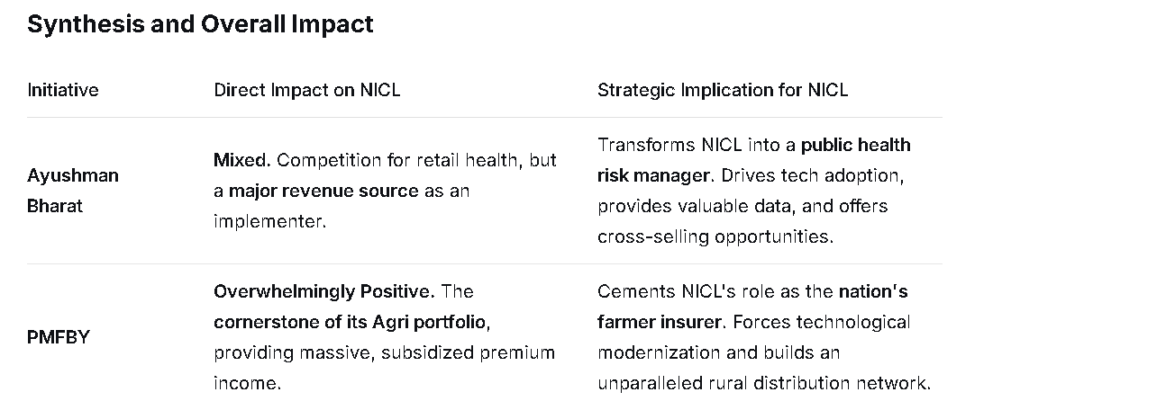
**Conclusion:**

Government initiatives like Ayushman Bharat and PMFBY have fundamentally reshaped NICL's business model. They have moved NICL from being just a commercial insurer to becoming an **arm of the state for social security implementation**.

While these schemes introduce competitive pressures in certain segments, their net effect is **highly beneficial** for NICL. They provide:
* **Guaranteed, large-scale premium volumes.**
* **Fulfillment of its public sector mandate.**
* **Opportunities for technological advancement and data analytics.**
* **Deepened market penetration,** especially in rural areas.

For NICL, the challenge is not whether these schemes are good or bad for business, but rather **how efficiently it can manage these massive portfolios** while leveraging the associated infrastructure and data to grow its complementary commercial lines of business.

    - **What is **IRDAI**'s role in protecting the policyholder's interests?
- IRDAI is the insurance watchdog. Its main job is to protect you, the policyholder.It creates all the rules and guidelines that every insurance company must follow.
Here's how it does that:
- Keeps Companies Stable: It makes sure insurance companies have enough money to pay your claims.
- Makes Policies Clear: It ensures policy wordings and Key Facts documents are simple to understand, so you know what you're buying.
- Stops Mis-selling: It sets strict rules for agents to prevent them from lying or hiding information to make a sale.
- Solves Complaints: It provides a free and fast grievance system, including the Insurance Ombudsman, if you have a problem with your insurer.
- Ensures Fair Claims: It forces companies to settle claims quickly and gives a valid reason if they reject one.
In short, IRDAI creates rules and systems to ensure you are treated fairly and get the benefits you were promised.

Its main jobs are:
- To Protect You: It makes sure insurance companies treat customers fairly and don't cheat them.
- Set the Rules: It creates all the rules and guidelines that every insurance company must follow.
- Control Prices: It approves the prices (premiums) of insurance products to keep them fair.
- Solve Problems: It helps you if you have a complaint against an insurance company.
In short: IRDAI is the government body that controls, regulates, and promotes all insurance companies in India to protect the people who buy insurance.

    - **What are your views on the increasing penetration of insurance in rural India?**

### The Positive Impact (The Opportunity)

1. **Financial Security for Millions:** It provides a crucial safety net for rural families, protecting them from catastrophic health expenses or crop failure, which are common causes of debt.
2. **Economic Resilience:** With schemes like PMFBY (crop insurance), farmers can recover from bad harvests and invest in the next season with confidence, stabilizing the agricultural economy.
3. **Women Empowerment:** The push for "**Insurance for All by 2047**" often involves women-centric schemes, giving women financial security and a say in family planning.
4. **Massive Business Growth:** For insurance companies (like NICL, LIC, and private players), it represents the largest untapped market, offering huge potential for growth in premium income.

### The Key Challenges

1. **Low Awareness & Trust:** Many people don't understand how insurance works or distrust the claims process due to past experiences or complexity.
2. **Affordability:** Despite low-premium schemes, insurance can still be a significant expense for low-income households.
3. **Last-Mile Connectivity:** Physically reaching remote villages and explaining products remains a major hurdle for companies.
4. **Claim Settlement Issues:** Delays or rejections of claims, especially in crop insurance, can erode trust and discourage new buyers.

### How It's Being Addressed

The government and regulators (IRDAI) are actively working to overcome these challenges through:
* **Simplified Products:** Like **Bima Vistar** (a straightforward bundled cover) and **Bima Sugam** (a digital platform).
* **Use of Technology:** Using drones for crop assessment and mobile apps for easier enrollment and claim filing.
* **Local Agents ("Bima Vahaks"):** Deploying local representatives to build trust and explain products in the local language.

**In summary:**

The increasing penetration is a **very positive and necessary trend**. It's transforming rural India from a vulnerable, uninsured population to a more financially secure one. While challenges of trust and access remain, focused efforts by the government and the industry are making insurance more inclusive, which is vital for the nation's overall economic health.

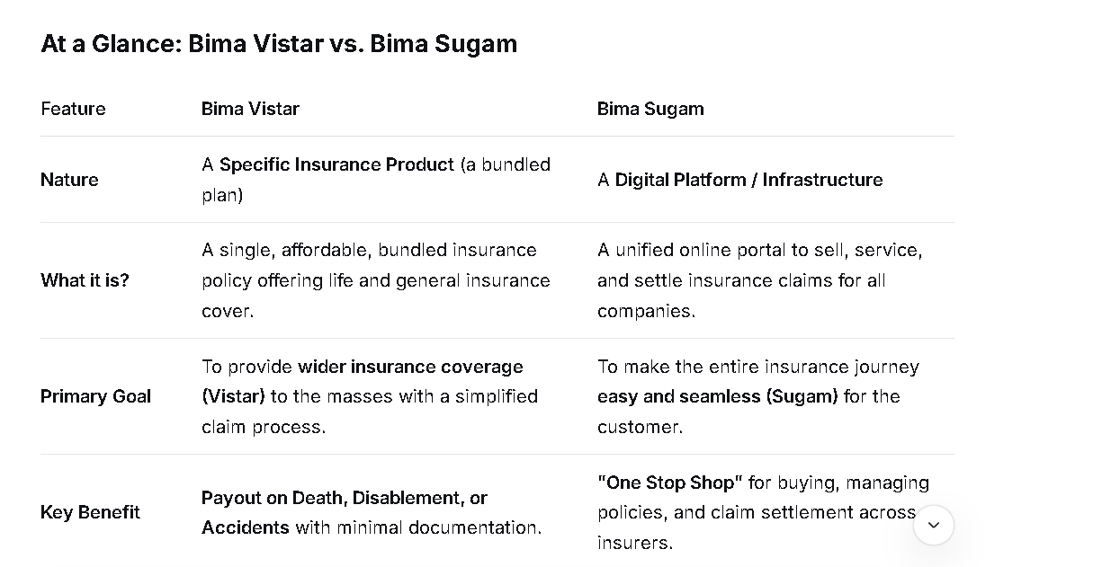

Detailed Explanation of Bima Vistar
Bima Vistar is a voluntary, bundled insurance product that combines life and general insurance cover into a single, straightforward policy.
Key Objectives:
- Simplification: To offer a simple product that is easy to understand for the common person.
- Affordability: To be priced reasonably to increase penetration in rural and underserved areas.
- Ease of Claim: To ensure quick and hassle-free claim settlement with minimal documentation.
Key Features:
- Single Policy: One policy number for both life and general insurance components.
- Defined Payout: It offers a pre-defined sum assured. Upon the occurrence of a covered event (like death, disability, or accident), a fixed amount is paid out directly to the beneficiary's bank account.
- Coverage: It typically covers:
  - Life Cover: Death due to any cause.
  - Accidental Death & Disability Cover.
  - Health Cover: For hospitalization expenses.
  - Asset Loss Cover: For damage to property (like a house) due to specific perils.
- No Middlemen: It is designed to be sold directly, often through Common Service Centres (CSCs), banks, and digital channels, to keep costs low.
- Minimal Documentation: The claim process requires minimal paperwork, aiming for a quick settlement.
Who is it for?
It is ideal for people in rural areas, low-income families, MSME employees, gig workers, and anyone who wants a simple, affordable, and comprehensive insurance safety net without the complexity of multiple policies.

Detailed Explanation of Bima Sugam
Bima Sugam is not an insurance product. It is a proposed digital public infrastructure that will act as a unified online platform for the entire insurance ecosystem.
Key Objectives:
- Unification: To bring all insurance companies (life, health, and general) onto a single platform.
- Digitization: To make the entire insurance lifecycle paperless and presence-less.
- Efficiency: To drastically reduce the time and effort required for buying and claiming insurance.
Key Features (Expected):
- One-Stop Shop: A single portal or app where you can:
  - Buy any insurance policy from any company.
  - Manage all your policies in one place (view, renew, port).
  - Service claims for any policy seamlessly.
- Faster Claim Settlement: The platform will use technology to verify and process claims quickly, often in an automated manner.
- Direct Benefit Transfer (DBT): Claim amounts will be directly transferred to the beneficiary's bank account.
- Standardization: It will create a standard, interoperable system for all insurers, reducing fraud and improving transparency.
- Insurance Repository: It will securely store all policy documents digitally (an "e-insurance account").
Who is it for?
Every insurance policyholder in India. It is designed to benefit anyone who has or plans to buy an insurance policy by making their experience as easy as online banking or e-commerce.

How They Work Together
While they are separate initiatives, they are complementary and part of the government's broader vision of "Insurance for All by 2047".
- Bima Vistar is the simple product you can buy.
- Bima Sugam is the easy platform you can use to buy it (along with all other policies), manage it, and make claims.
You could, for example, use the Bima Sugam platform to purchase a Bima Vistar policy, and later, use the same platform to file and track a claim for that same policy.
In summary:
- Think of Bima Vistar as the "what" – a specific, bundled insurance scheme.
- Think of Bima Sugam as the "how" – the digital highway that makes accessing and managing all insurance, including Bima Vistar, simple and efficient.

Bima Vahak
The Bima Vahak scheme is a flagship initiative by the Insurance Regulatory and Development Authority of India (IRDAI) aimed at deepening insurance penetration in rural areas by creating a last-mile distribution network.
The name itself is very descriptive:
- Bima = Insurance
- Vahak = Carrier / Messenger / Transporter
So, a Bima Vahak is essentially an "Insurance Carrier" who brings insurance products directly to the doorstep of people in rural and remote areas.

Key Objectives of Bima Vahak
The primary goals are:
- Last-Mile Connect: To establish a dedicated distribution channel that reaches the grassroots level (villages and small towns) where traditional insurance agents and offices are absent.
- Trust Building: To create a local, trusted individual who can educate rural populations about the importance of insurance in their local language.
- Simplify Insurance: To make purchasing and claiming insurance simple for people who may be unfamiliar with formal financial processes.
- Women Empowerment: The scheme specifically encourages the participation of women as Bima Vahaks, aiming to create financial inclusion and entrepreneurship opportunities for them.

Who is a Bima Vahak?
A Bima Vahak is a grassroots-level insurance agent. Think of them as the "Anganwadi worker" or the "ASHA worker" for the insurance sector.
Profile:
- Typically a resident of the local area (a village or a cluster of villages).
- Has a good reputation and is trusted by the community.
- Often, the scheme encourages the recruitment of women to take up this role.

Key Features of the Scheme
- Doorstep Service: The Bima Vahak's main role is to travel door-to-door to educate, sell simple, tailored insurance products (like Bima Vistar), and provide policy servicing.
- Digital-First Approach: They are equipped with a digital hand-held device or a smartphone with a dedicated app. This allows for:
  - On-the-spot enrollment and issuance of policies.
  - Collection of premiums (in cash, which is then reconciled digitally).
  - Immediate assistance in initiating claims.
- Limited Product Portfolio: They do not sell complex products. They offer curated, simple, and affordable life, health, and property insurance products that are easy to understand for the rural population.
- Revenue Model: Bima Vahaks earn a commission from the insurance company for the policies they sell. The scheme ensures a sustainable earning model to motivate them.
- Grievance Redressal: They act as the first point of contact for any customer complaints or queries, ensuring policyholders don't have to travel to a distant town for support.

    - **How can technology like **AI** and **big data** be leveraged to improve insurance services?**

AI and Big Data are transforming insurance services by enabling far more accurate risk assessment, faster operations, and highly personalized customer experiences.¹

🚀 Key Applications of AI and Big Data in Insurance

1. Risk Assessment and Underwriting²
AI, powered by Big Data analytics, moves underwriting from traditional, static models to dynamic, real-time risk profiles.³
- Granular Data Analysis: Machine Learning (ML) algorithms analyze massive datasets, including demographic, geospatial, real-time behavioral data (from IoT devices/telematics), and historical claims data.⁴
- Dynamic Pricing: This analysis allows for Usage-Based Insurance (UBI), where premiums for auto or life insurance can be adjusted based on actual driving behavior, health data from wearables, or facility conditions, ensuring fairer and more accurate pricing.⁵
- Automation: AI automates the processing of applications, instantly triaging them, enriching data from external sources, and even making automated approval/decline decisions for simple cases, reducing policy approval time from days to minutes.⁶

2. Claims Management and Processing
Technology significantly expedites and improves the accuracy of the claims process.⁷
- Automated Claims Triage: AI analyzes the "First Notice of Loss" (FNOL) documents (text, images, video) using Natural Language Processing (NLP) and computer vision to instantly classify claim severity, estimate damage, and route the claim to the right adjuster.⁸
- Faster Settlements: Routine and low-complexity claims can be processed and settled automatically without human intervention, dramatically reducing resolution times and improving customer satisfaction.⁹
- Damage Assessment: AI can analyze photos of damaged property or vehicles to provide an immediate repair cost estimate, speeding up the payout process.¹⁰

3. Fraud Detection and Prevention
AI excels at identifying anomalies and suspicious patterns that human investigators might miss.¹¹
- Pattern Recognition: ML models are trained on historical fraud data to monitor transactions, applications, and claims in real-time.¹²
- Anomaly Detection: They flag inconsistencies across multiple data sources (e.g., comparing claim details to social media activity or public records) to identify high-risk cases that require further investigation, saving the insurer billions annually.¹³

4. Enhanced Customer Experience and Personalization¹⁴
Insurers can use data to offer tailored products and seamless service.¹⁵
- Hyper-Personalization: Big Data insights help insurers understand individual customer needs, preferences, and risk tolerance, leading to highly customized policy offerings and bundled products.¹⁶
- 24/7 Support: AI-powered chatbots and virtual assistants handle routine inquiries (e.g., quote generation, policy updates, initial claims filing) instantly, offering 24/7 service and freeing up human agents for complex tasks.¹⁷
- Predictive Retention: Predictive analytics models identify customers likely to leave (churn risk) so that insurers can proactively offer personalized incentives or address pain points to improve loyalty.

### Category 5: Personal Motivation & Strengths

These are standard but crucial.

  - **Why should we hire you over other candidates for the AAO position?

My four years at Reliance Jio, working on major projects like 4G and 5G, have taught me how to build and manage very large, reliable, and secure technology systems, that bring digital transformation in india.
This experience is directly valuable to NICL because you need that same level of reliability and security to protect the financial data of millions of policyholders.

I believe my unique value lies in my four years of hands-on experience at Reliance Jio, I worked on the project like 4G and 5G one of the world's largest and most complex digital networks that brings digital transformation in India. This has teach me a deep sense of responsibility for system reliability, security, and scalability—principles that are absolutely critical for a national institution like NICL which handles the financial security of millions of citizens.

I understand that a public sector giant like NICL is focused on modernizing its legacy systems and enhancing digital customer experience. My work at Jio involved:

  - What are your strengths and weaknesses?

I am a hardworking and self-motivated person. I learn quickly and can easily adapt to new challenges and technologies.

  - Where do you see yourself in the next 5 years in this organization?

For the first 1-2 years:
My first goal is to learn everything about NICL's IT systems and how things work here. I want to become a reliable and knowledgeable team member who can handle my duties well and support my team on all our projects.
For the next 3-5 years:
Once I have a strong foundation, I plan to become an expert in an important area for NICL, like cybersecurity or data analytics. I see myself leading more complex projects, helping to train new employees, and growing into a senior technical role where I can help plan NICL's technology future.

**Pro Tip:** For behavioral questions (like "Describe a situation..."), use the **STAR method**:
* **S**ituation: Briefly describe the context.
* **T**ask: What was your goal?
* **A**ction: What specific steps did *you* take?
* **R**esult: What was the outcome? Quantify it if possible.

Good luck with your interview! Thorough preparation on these fronts will make you a confident and compelling candidate.

Insurance is a risk sharing mechanism, in which two parties are involved one in insurer and other is insured, where insured pay regular (a "premium"), in place of the insureser provide safety net for unexpected event of loss and damage.

National Insurance Company Limited (NICL) is an Indian public sector insurance company owned by the Government of India and administered by the Ministry of Finance. It is headquartered at Kolkata and was established in 1906 by Gordhandas Dutia and Jeevan Das Dutia. National Insurance company and Asian Insurance company was nationalised in 1972.
It provides non-life insurance policies to individuals and businesses. This includes:
- Motor Insurance (Car & Bike)
- Health Insurance
- Home Insurance
- Travel Insurance
- Crop Insurance
- Commercial Business Insurance.

## Underwriting.
Underwriting is the process where the insurance company decides:
- WHETHER they should insure a person or a thing (e.g., a car, house, or a person's life).
- AT WHAT PRICE (the premium) they should insure it.
- ON WHAT TERMS AND CONDITIONS the insurance will be provided.

Why is Underwriting Important?
- For the Company: It ensures they don't take on too many risky clients, which could lead to too many claims and financial losses.
- For You (the customer): It ensures that everyone pays a fair premium based on their individual risk level. Safe drivers shouldn't have to pay the same high price as reckless drivers.
In short, underwriting is the core process of risk assessment and selection that keeps the insurance business running fairly and profitably.

Pure Premium is the theoretical minimum amount needed to cover expected claims only.
Premium = Pure Premium + Expense Loading + Risk Loading + Profit Margin
Turn Around Time (TAT) is simply the total time taken to complete a process from start to finish.
In insurance, it's the time between you making a request and the insurance company giving you a final outcome.

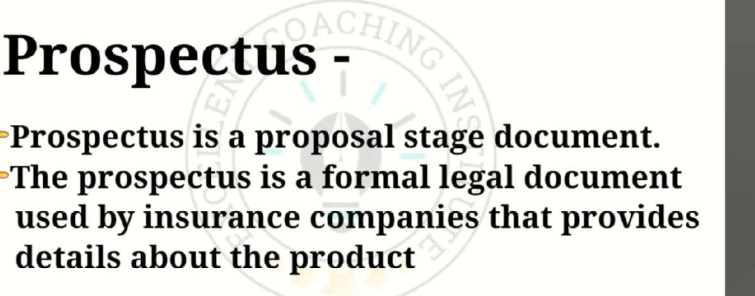
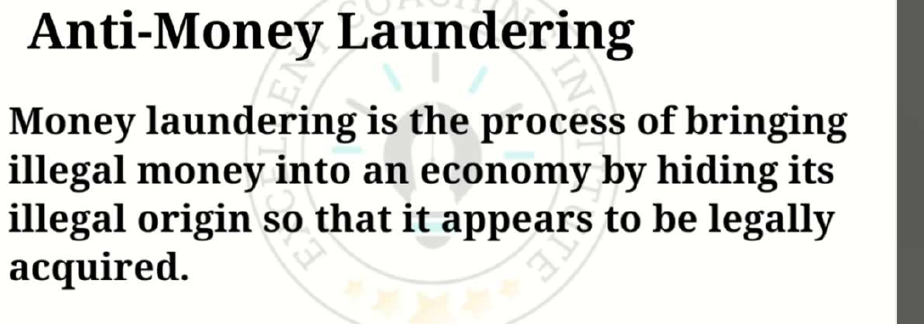

### **In Simple Terms**

The Redressal of Public Grievances Rules, 1998, established the **Insurance Ombudsman scheme** in India. It's a system to help you resolve complaints against insurance companies quickly, fairly, and for free, without going to court.
### **Key Features in a Nutshell**

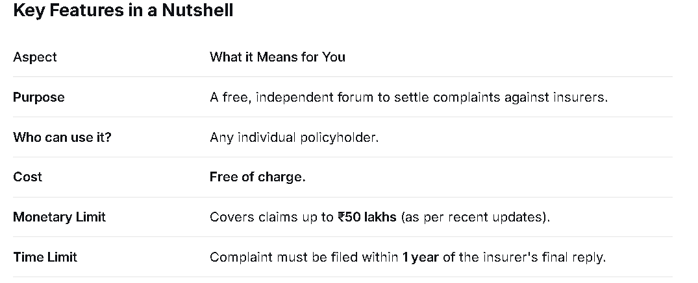

### **What Complaints Can the Ombudsman Handle?**

The Ombudsman can hear complaints about:

1. **Claim Delays or Denials:** e.g., "My claim has been pending for over 6 months."
2. **Policy Terms Disputes:** e.g., "The company is not honoring the policy wordings."
3. **Mis-selling:** e.g., "The agent misled me about the policy benefits."
4. **Premium Issues:** e.g., "The company is not issuing my policy document after collecting the premium."
5. **Partial Settlement:** e.g., "The company is offering a lower amount than what I am eligible for."

#### **Step 1: Complain to the Insurance Company First**
You must first write to the insurer's grievance cell and wait for:
* Their reply, OR
* 30 days have passed with no reply.

#### **Step 2: Approach the Ombudsman**
If unsatisfied with the insurer's reply (or if they don't reply), you can file a complaint with the Ombudsman.
* **Fill a Form:** Get the complaint form from the Ombudsman's office or their website.
* **Write a Letter:** You can even write a simple, plain letter detailing your grievance.
* **Submit:** Send it by post, email, or submit it in person.

#### **Step 3: The Proceedings**
* The Ombudsman will call both you and the insurance company for a hearing.
* The process is informal and not like a court.
* The Ombudsman listens to both sides and examines the documents.

#### **Step 4: The Decision (Award)**
The Ombudsman can pass an **Award**, which is a final decision. The Ombudsman can order the insurer to:
* Pay the claim amount.
* Change the policy terms.
* Refund the premium.
* Pay compensation for the loss or hardship suffered.

---### **What Happens After the Award?**

* The insurance company **must comply** with the award within 30 days.
* If you are not satisfied with the award, you can appeal to the **Consumer Forum or a Civil Court** within 3 months.

### **Summary: Why This Rule is Important for You**

The Redressal of Public Grievances Rules, 1998, gives you a powerful, **free, and fast** weapon against insurance companies. It ensures that as a common policyholder, you have a fair chance to get justice without the cost and delay of legal proceedings.

**In short: It's your right to a quick and fair solution for insurance-related problems.**

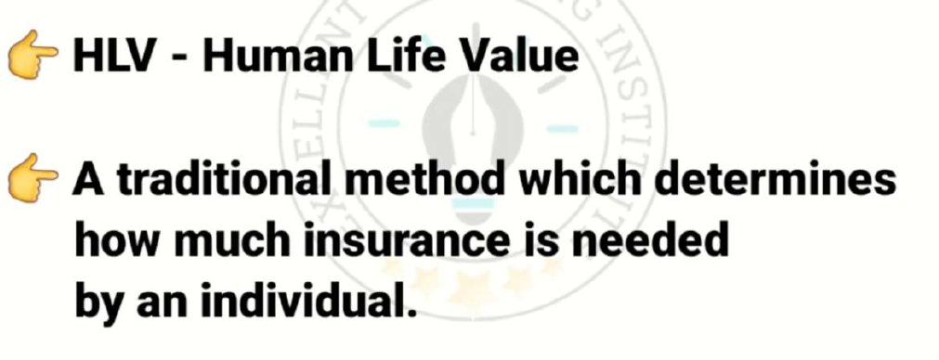
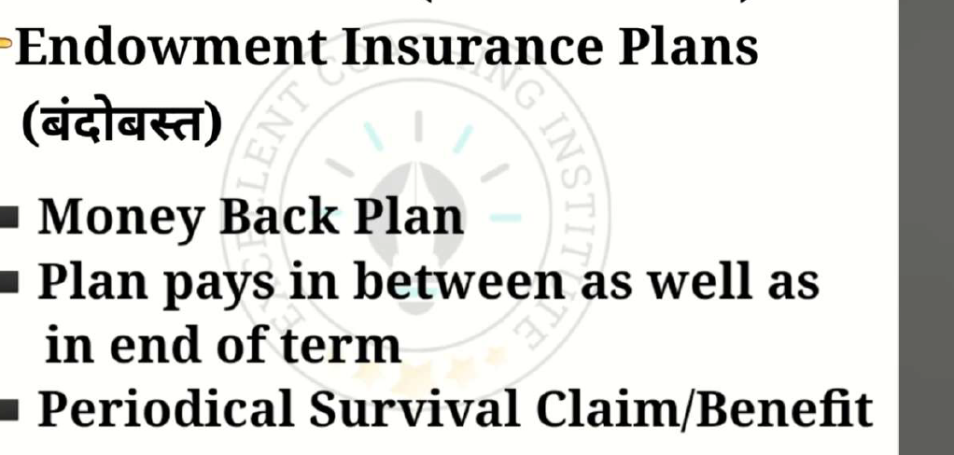

Simple Explanation of a ULIP / Variable Insurance Plan
Think of it as a 2-in-1 product that combines Insurance and Investment in a single plan.
- Part 1: Insurance: A part of your money pays for a life insurance cover to protect your family.
- Part 2: Investment: The rest of your money is invested in market-linked funds (like stocks and bonds) to grow your wealth.
The "Variable" in the name refers to the fact that your returns are not fixed or guaranteed; they vary (go up and down) based on how the market performs.

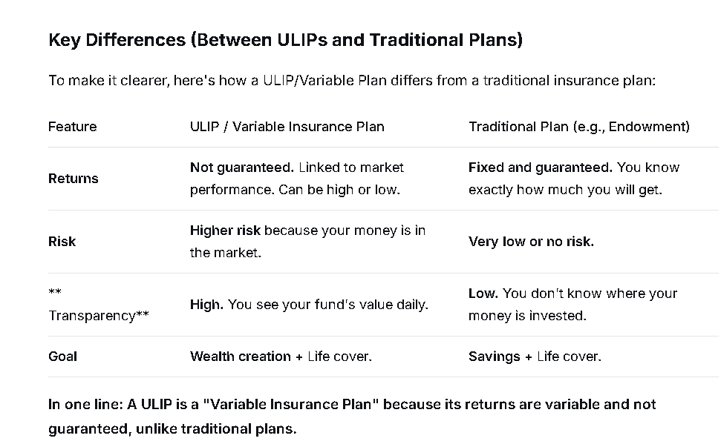

What is a ULIP?
A ULIP (Unit Linked Insurance Plan) is a single product that combines Insurance (life cover) + Investment (in stocks/bonds).
Think of it as buying a single combo meal that has both a burger (insurance) and fries (investment).

How does a ULIP work?
- You Pay Premium: You pay a regular amount to the insurance company.
- Company Deducts Charges: The company first takes out some money for its fees and the insurance cost. These are called "charges".
- The Rest is Invested: The remaining money is invested in funds of your choice (e.g., Stock Market Fund, Debt Fund).
- You Get "Units": Your money is used to buy "units" of these funds, just like buying shares of a mutual fund.
- Value Fluctuates: The value of your units goes up and down daily based on market performance.

Key Features of ULIPs
1. Two-in-One Product
- Insurance Part: Provides a life insurance cover. If you die, your family gets the sum assured.
- Investment Part: The potential for your money to grow with the market.
2. Transparency
- You can see the value of your investment (NAV) every day.
- You know exactly how much is being charged.
3. Flexibility
- You can switch between different funds (e.g., from equity to debt) as per market conditions.
- You can increase or decrease your insurance cover (within limits).
4. Lock-in Period
- ULIPs have a 5-year lock-in period. You cannot withdraw your money during this time.
5. Tax Benefits
- Premiums paid qualify for tax deduction under Section 80C.
- Maturity amount is tax-free under Section 10(10D).

Pros and Cons of ULIPs
ADVANTAGES:
✅ Life cover + investment in single product
✅ Potential for higher returns than traditional plans
✅ Transparency in charges and fund value
✅ Flexibility to choose and switch funds
DISADVANTAGES:
❌ Market risk - your returns are not guaranteed
❌ Various charges reduce your returns
❌ 5-year lock-in period
❌ Requires active monitoring and fund management

Who should invest in ULIPs?
- People looking for both insurance and investment
- Those comfortable with market risks
- Investors with a long-term horizon (at least 7-10 years)
- People who will actively monitor and manage their funds
Important: ULIPs are different from pure term insurance. If you need only insurance protection, term plans are better and cheaper. ULIPs are for those who want insurance plus market-linked growth.

1. Stocks (also called Shares or Equity)
- What it is: A small piece of ownership in a company.
- Simple Example: If a company is like a pizza, one stock is one slice of that pizza.
- How you make money:
  - The pizza (company) becomes more valuable, so your slice (stock) is worth more. You sell it for a profit.
  - The company shares a part of its profit with the owners (this is called a dividend).
- Risk: High. If the company does poorly, the value of your slice can go down.

2. Bonds
- What it is: A loan you give to a company or government.
- Simple Example: It's like an I.O.U. They borrow your money and promise to pay you back on a specific date with regular interest payments.
- How you make money: You earn fixed interest over time.
- Risk: Medium to Low. It's generally safer than stocks because you're a lender, not an owner. But if the company/government fails, they might not pay you back.

3. Equity
- This is just another word for Stocks. If you own "equity" in a company, it means you own its stocks or shares. It means you have an ownership stake.

4. Treasuries (Government Bonds)
- What it is: A specific type of bond issued only by the government.
- Simple Example: It's when you lend money directly to the government. The government uses it to build roads, schools, etc.
- How you make money: You earn a fixed interest.
- Risk: Very Low. It's considered one of the safest investments because it's very unlikely the government will fail to pay you back.

Summary Table
Instrument | What are you? | Simple Idea | Risk Level
Stocks / Equity | Owner | Buying a slice of a company | High
Bonds | Lender | Giving a loan to a company/government | Medium
Treasuries | Lender to Govt. | Giving a loan specifically to the government | Very Low
In short:
- Want ownership and are okay with risk for higher returns? Think Stocks/Equity.
- Want to be a lender and get steady income with more safety? Think Bonds.
- Want the safest possible place for your money? Think Treasuries.

1. Arogya Sanjeevani Policy (Standard Health Plan)
What it is: A basic, standardized health insurance plan that every health insurance company in India must sell. It was created by the insurance regulator (IRDAI) to provide affordable and simple health coverage to everyone.
Key Features:
- Standardized: The main features are the same across all companies, making it easy to compare.
- Covers Hospitalization: It pays for room rent, doctor's fees, medicine costs, etc., if you are admitted to a hospital for at least 24 hours.
- Pre & Post Hospitalization: Covers medical expenses for 30 days before and 60 days after hospitalization.
- No Frills: It does not cover things like maternity, day-care treatments (without 24-hour admission), or Ayush treatments in detail.
- Affordable: It is designed to be a low-cost, entry-level health insurance plan.
Who is it for?
It's a good fit for someone looking for their first health policy or anyone who wants a simple, affordable plan for basic hospitalization coverage.

2. Jeevan Aastha Policy (Life Insurance Plan)
What it is: A single-premium, non-linked savings insurance plan from LIC (Life Insurance Corporation of India). "Non-linked" means your money is not invested in the stock market.
Key Features:
- Single Premium: You pay the entire premium amount as a one-time, lump-sum payment.
- Fixed Returns: It offers a guaranteed benefit. You know exactly how much you will get at the end of the policy term.
- Life Cover: It provides life insurance protection, meaning your nominee gets the sum assured if you die during the policy term.
- Low Risk: Since it's not market-linked, it is a very safe and secure investment. Your returns are fixed and guaranteed.
Who is it for?
It's for risk-averse investors who want a safe, fixed-return instrument with a life cover and have a large lump sum to invest at one time.

Simple Comparison
Feature | Arogya Sanjeevani (Health) | Jeevan Aastha (Life)
Type | Health Insurance | Life Insurance + Savings
Main Purpose | Pay for hospital bills | Savings with life cover
Risk | Covers health risk | Zero market risk (safe)
Premium | Paid yearly | One-time lump sum payment
Returns | No returns, only coverage | Fixed, guaranteed return

National Insurance Company Limited (NICL) is one of India's oldest and most trusted public sector insurers. They are best known for their "Mediclaim" series of health policies, which have been a standard in the Indian market for decades.
Below are their most famous and widely purchased insurance products, categorized by type:

1. Flagship Health Insurance (Mediclaim)
These are NICL's most popular products. The term "Mediclaim" itself became synonymous with health insurance in India largely due to these policies.
- National Mediclaim Policy: The classic individual health plan. It is an indemnity policy that covers hospitalization expenses, including Ayurveda and Homeopathy. It is known for being cost-effective and straightforward.
- National Parivar Mediclaim Policy: A highly popular family floater plan. A single sum insured covers the entire family (Self, Spouse, Children, and Parents). It is famous for its affordability compared to private insurers.
- National Mediclaim Plus Policy: An enhanced version of the standard Mediclaim. It offers higher sum insured options (up to ₹50 Lakhs), covers maternity expenses, and includes features like air ambulance and medical second opinions.
- Varistha Mediclaim Policy: Designed specifically for Senior Citizens (aged 60-80). It covers hospitalization as well as critical illnesses. It is one of the few government-backed policies specifically tailored for the elderly.

2. Motor Insurance
NICL has a massive market share in vehicle insurance, often favored for claims settlement reliability in government and PSU sectors.
- Private Car Package Policy: A comprehensive policy covering Own Damage (accidents, theft, fire) and Third-Party Liability.
- Two-Wheeler Package Policy: Similar comprehensive coverage for bikes and scooters.
- Long-Term Two-Wheeler Policy: A famous product that allows bike owners to insure their vehicle for 2 or 3 years in one go to avoid yearly renewals.

3. Personal Accident Insurance
- National Individual Personal Accident Policy: A very low-cost policy that provides a lump sum payout in case of accidental death or disability (Permanent Total/Partial). It also offers a children's education bonus in case of the policyholder's death.
- Janata Personal Accident Policy: A mass-market product designed to be extremely affordable (premiums as low as a few hundred rupees) to provide accident coverage to the general public.

4. Rural & Other Products
- Pradhan Mantri Fasal Bima Yojana (PMFBY): While this is a government scheme, NICL is a major implementer, providing crop insurance to farmers against non-preventable natural risks.
- Overseas Mediclaim Policy: A travel insurance product for Indians travelling abroad for business or holidays, covering emergency medical expenses overseas.

Summary: Which one is the "Most Famous"?
If you had to pick just one, the National Mediclaim Policy (and its family variant, Parivar Mediclaim) is their signature product. It is the policy most people refer to when they talk about "National Insurance."
Would you like me to compare the premiums or features of the National Parivar Mediclaim against a private insurer's plan?

1. Term Insurance (Pure Protection)
- What it is: The simplest and purest form of life insurance.
- Simple Idea: You pay a premium for a fixed period (term). If you die during that period, your family gets a large sum assured. If you survive, you get nothing back.
- Goal: To provide a high life cover at a very low cost.
- Best for: Young people who need a large safety net for their family at an affordable price.
Example: Pay ₹10,000 per year for 30 years for a ₹1 Crore cover. If you die within 30 years, family gets ₹1 Crore. If you survive, you get nothing.

2. Whole Life Insurance (Protection for Life)
- What it is: A policy that covers you for your entire life, not just a specific term.
- Simple Idea: You pay premiums for a limited period (e.g., 15-20 years) or your whole life, and the policy remains active until you die. Upon death, your nominee gets the sum assured.
- Goal: To provide lifelong coverage and sometimes build cash value over a very long period.
- Best for: Someone who wants a life cover that never expires.

3. Endowment Policy (Protection + Savings)
- What it is: A combo plan that provides both life insurance and savings.
- Simple Idea: You pay premiums for a specific term. If you die during the term, your family gets the sum assured. If you survive the term, you get back the sum assured plus bonuses. It's a forced savings plan with insurance.
- Goal: To save money systematically and get a lump sum at maturity, with life cover as a bonus.
- Best for: Risk-averse people who want to save and get a guaranteed return with life cover.
Example: Pay ₹50,000 per year for 20 years. If you die, family gets ₹10 Lakhs. If you survive, you get ₹12 Lakhs back at the end of 20 years.

4. Mortgage Insurance (A Type of Term Insurance)
- What it is: It is essentially a term insurance policy specifically designed to pay off a home loan if you die.
- Simple Idea: The sum assured is equal to your outstanding home loan amount. If you die, the insurance company pays the bank directly, and your family gets the house free of debt.
- Goal: To protect your family from the burden of a home loan EMI.
- Best for: Anyone who has taken a home loan.

Summary Table
Policy Type | Main Goal | Do you get money back if you survive? | Risk | Cost (Premium)
Term Insurance | High Protection | No | Pure Risk | Lowest
Whole Life | Lifelong Protection | Yes (to nominees after death) | Low | Medium to High
Endowment | Savings + Protection | Yes | Very Low | High
Mortgage Insurance | Pay off Home Loan | No (The bank gets the payout) | Pure Risk | Low

1. Maturity Benefit at a Predetermined Age (Most Common in India)
In India, most Whole Life policies are structured to mature when the policyholder reaches a specific age, like 80, 85, or 90 years.
- What happens: If you are alive when you reach this pre-set age (e.g., 90), the insurance company pays you the ****Sum Assured plus any accrued bonuses. This is your maturity benefit.
- After this payout, the policy terminates. You are no longer insured.

2. Surrender or Paid-Up Value (If you stop paying premiums)
- Paid-Up Value: If you stop paying premiums after a certain number of years, the policy becomes "paid-up." It continues, but with a reduced sum assured. Upon your death or at the maturity age, your nominee/you will receive this reduced amount.
- Surrender Value: If you decide to cancel the policy entirely, the insurer will pay you a lump sum called the "surrender value," and the coverage will end.

City information
Nahan is town of ponds. It was founded in 1621 by Raja Karam Prakash. The word "Nahar" is said to mean "do not kill," and the name Nahan is believed to have originated from an incident in which a saint stopped a king from killing a lion by uttering the word "Nahar.
Major attraction are the such as Renuka Lake, Paonta Sahib, Trilokpur, and the Suketi Fossil Park.
Renuka lake is in the Sirmaur district of Himachal Pradesh in India and it is 672 m above the sea level.^{[1]} It is the largest lake in Himachal Pradesh, with a circumference of about 3214 m.^{[1]} This lake was named after the goddess Renuka and is a designated Ramsar site since November 2005.
he town was founded by Sikh Guru Shri Guru Gobind Singh in 1685. The name Trilok Pur means a triangle of three Shakti Temples in the area. Each temple depicts a different face of the Goddess Durga.

Why Other countries develop AI not India
They invest Billions in venture capital and government funding.They have Powerful computers, cloud resources, expensive GPUs. Very costly for Indian startups/universities.
Indian IT companies focused on services (outsourcing) rather than product innovation.

Governor of Himachal pardesh
Mr Shive Pratap Shukla
Rohit thakur is education minister

Devendra Fadnavis CM of mahrashtra
Acharya Devvrat Governor

